March 2020
Music Fun At Home

Hello Year 3!

I hope you are enjoying learning at home! It is a little bit different to being in school, I am sure it is just as much fun!

I have found you some interesting music videos for you to watch which explain all about sound. I hope you will enjoy learning some interesting facts about your ears, some different instruments and some musical pieces that we will be looking lat ater.

To find the videos on your computer or table, you need to click here:

https://www.bbc.co.uk/teach/class-clips-video/music--science-ks2-house-of-sound/zncr7nb

This is what the front page screen looks like: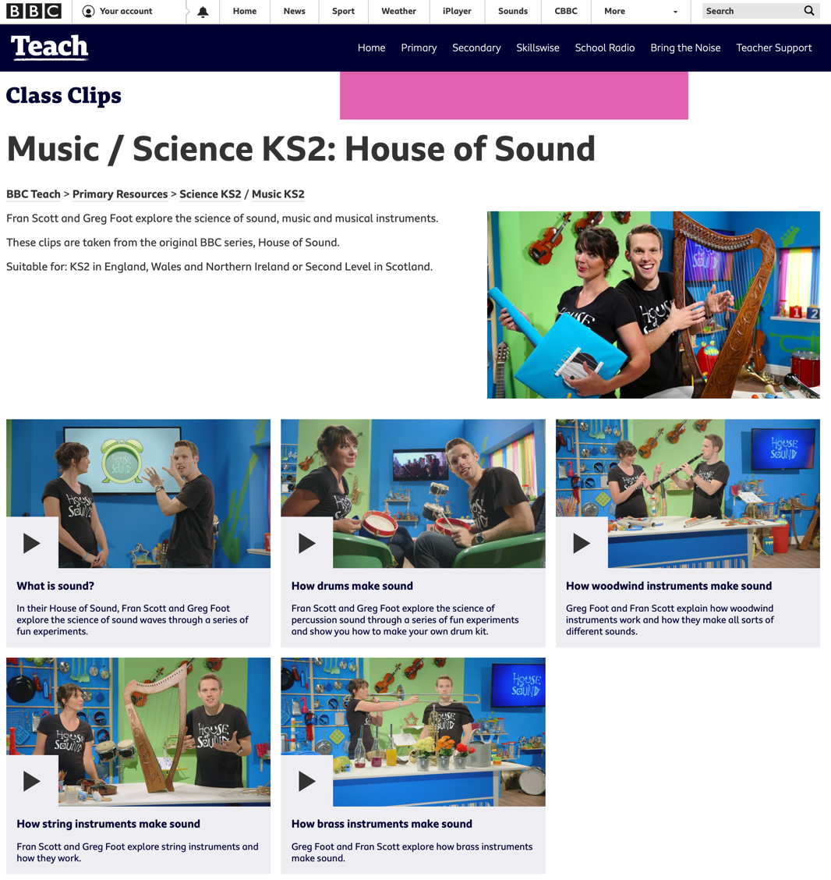

From this screen, you can click on the lesson you want to listen to. Or, you can click on the lesson link below.

There are five lessons:
- What is sound?
- How string instruments make sound
- How drums make sound
- How brass instruments make sound
- How woodwind instruments make sound

There is also a link to the piece of music that is mentioned in the video.

Note to parents and carers: watching the related music videos will help to reinforce the learning of the lesson.

Lesson One – What is sound?
https://www.bbc.co.uk/teach/class-clips-video/music--science-ks2-what-is-sound/zbnmhbk
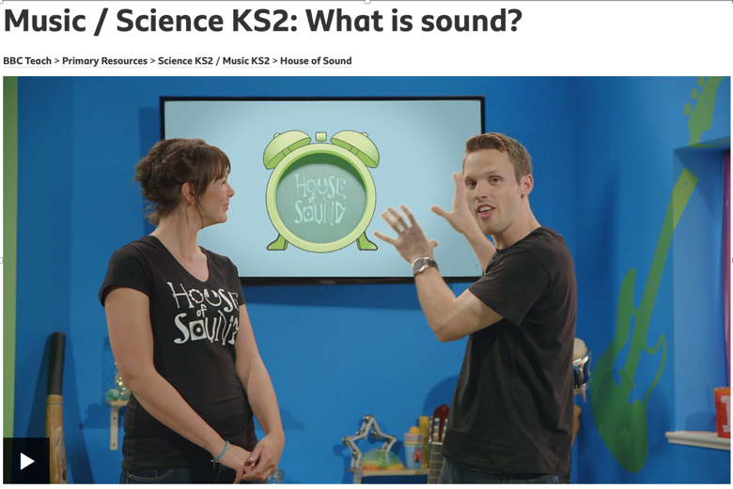

- In this lesson, we explore the science of sound waves through a series of fun experiments.
- We learn that sound is caused by vibration. If an object vibrates the air particles called molecules close to it vibrate.
- This makes the molecules next to them vibrate and so on, forming a sound wave.
- If the sound wave reaches our ears and our brains then we hear the sound.
- We learn that sound needs something called a medium to travel through and see a famous experiment by a scientist called Robert Boyle who demonstrated that air is a medium through which sounds travel.
- A bell is put in a jar, and all the air is taken out to create a vacuum – the bell falls silent.
- There is a guided tour of the human ear, pointing out the key components: the eardrum, hammer, anvil, stirrup, cochlea and auditory nerve.
- We see a giant human ear made out of everyday things to show how these components work.
Musical piece in full – Connect It – Anna Meredith
https://www.bbc.co.uk/teach/ten-pieces/KS2-anna-meredith-connect-it/zhyyb82

Lesson Two – How string instruments make sound
https://www.bbc.co.uk/teach/class-clips-video/music--science-ks2-how-string-instruments-make-sound/zfmd7nb
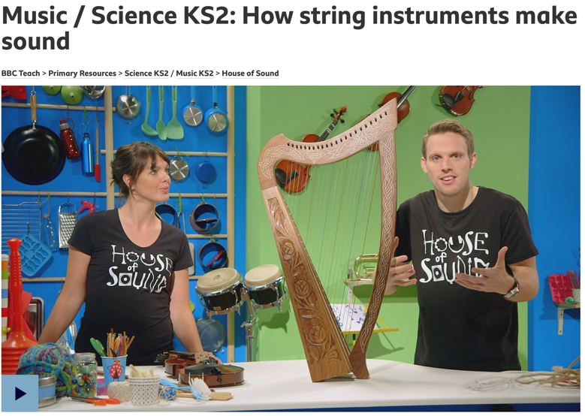

- In this lesson, we find out about string instruments, how they work and make such different sounds.
- We look inside a piano and see long, thick strings that make low notes, and short, thin strings that make high notes.
- We see the strings of a cello vibrating and see that thick strings vibrate more slowly than thin ones, which explains the difference in their pitch. Thick strings give a low pitch, thin strings give a high pitch.
- The tightness or tension of a string is also important. The tighter the string, the higher the pitch. The less tight a string, the lower the pitch.
- We see how it is easy to make a guitar out of an old cardboard box and some elastic bands (sort of!).
Musical piece in full – Beethoven’s Fifth Symphony
https://www.bbc.co.uk/teach/ten-pieces/KS2-ludwig-van-beethoven-symphony-no-5-1st-movement/zrsf3k7
Lesson Three – How drums make sound
https://www.bbc.co.uk/teach/class-clips-video/music--science-ks2-how-drums-make-sound/z6wc8xs

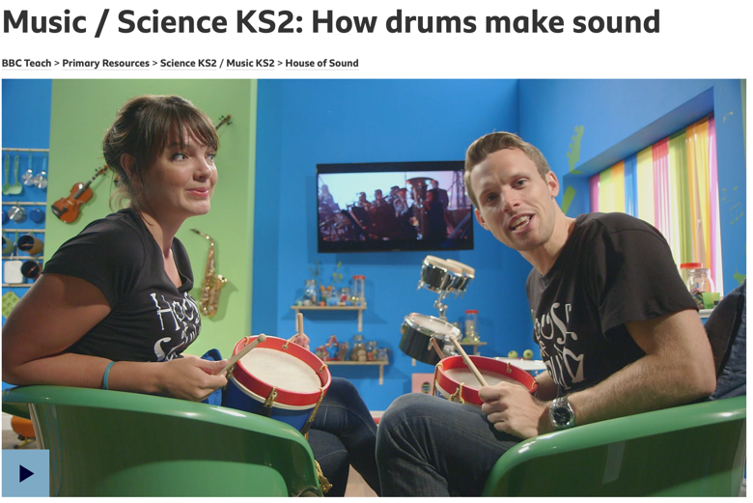
- In this lesson, we find out how drums work.
- Drums have been around for thousands of years and throughout history have often been involved in warfare - something we are reminded of as they play along to Mars from Holst’s The Planets suite.
- Using confetti placed on a drum we see how confetti behaves like air molecules when the drum is struck.
- The skin of the drum vibrates and makes the confetti dance.
- As the air molecules vibrate against each other, sound waves are formed and the sound of the drums can be heard.
- We learn that the pitch of a drum depends on how tight its skin is. If the skin is tight the drum makes a high note, if it is slack it makes a low note.
- We see that the amount of air inside a drum also influences its pitch. The more air in a drum, the lower the note. The less air in a drum, the higher the note.
- Volume depends on the size of the vibrations that are made.
- Hit a drum hard and this makes big vibrations and a loud sound.
- Hit a drum softly and the vibrations are smaller and the sound not as loud.
- We see how to make a drum kit out of things that can be found around the house, e.g. a plastic bowl and half a balloon.
Musical piece in full – Mars from Gustav Holst’s The Planets
https://www.bbc.co.uk/teach/ten-pieces/KS2-gustav-holst-mars-from-the-planets/zf6hsrd

Lesson Four – How brass instruments make sound
https://www.bbc.co.uk/teach/class-clips-video/music--science-ks2-how-brass-instruments-make-sound/zknmhbk
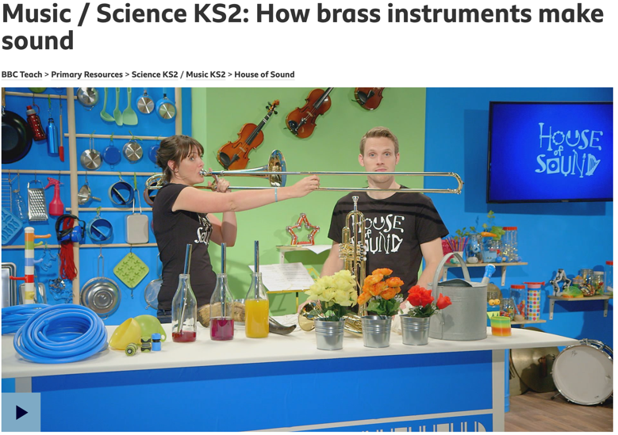

- In this lesson, we find out about brass instruments and how they make their loud, bright sounds.
- We learn that in order to make a sound, a brass player's lips must be made to vibrate very, very quickly. When placed against the mouthpiece of the instrument the air inside begins to vibrate, forming sound waves.
- To make different notes the amount of air vibrating inside the instrument has to be changed.
- On a trombone, a part called the slide makes the tube of air that vibrates longer or shorter, and this changes the pitch of the note from lower to higher.
- On an instrument like a trumpet, three parts called valves can be pressed down to change the amount of air.
- We see how a sound wave travels using a large metal spring and form a standing wave with a length of rope.
- We learn how to easily make a simple horn from a funnel, length of hose pipe and a hosepipe connector for a mouthpiece.
Musical piece in full – Horn Concerto No. 4 - Mozart
https://www.bbc.co.uk/teach/ten-pieces/KS2-wolfgang-amadeus-mozart-horn-concerto-no-4-3rd-movement/zmxtng8

Lesson Five – How woodwind instruments make sound
https://www.bbc.co.uk/teach/class-clips-video/music--science-ks2-how-woodwind-instruments-make-sound/zk3py9q
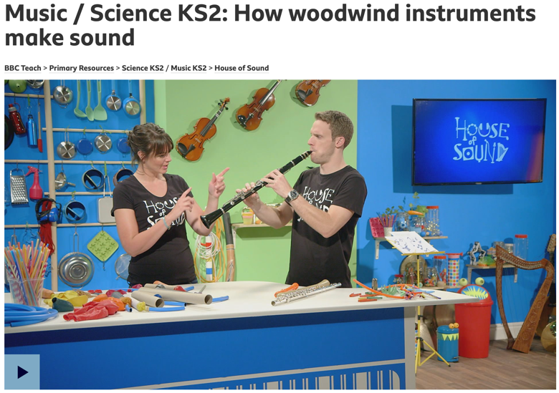

- In this lesson, we find out about woodwind instruments and how they make all sorts of different sounds.
- We find out that lots of woodwind instruments are not even made of wood, and to prove the point we see a woodwind instrument made out of a carrot simply by making a few holes in it.
- The pitch of a woodwind note depends on the amount of air that is vibrating inside the instrument.
- To prove this, we see a fun experiment where simple flutes out of drinking straws and make them play higher notes just by cutting bits off to make them shorter.
- We see that on a clarinet and a recorder, musicians use their fingers to cover up holes in the instruments to change how much air is inside.
- Cover up just one hole and less air can vibrate which makes a high note.
- Cover them all up and more air vibrates making a lower note.
- We are shown how to make a balloon clarinet out of a piece of cardboard tube, a balloon and an elastic band.
Musical piece in full – Short Ride in A Fast Machine – John Adams
https://www.bbc.co.uk/teach/ten-pieces/ks2-john-adams-short-ride-in-a-fast-machine/zkthsrd

I hope you enjoy watching these videos and listening to the music! Please let me know how you get on and what you have learned. When we are all back at school, perhaps we could make some of the instruments you have seen. You could have a go with a carrot at home! I’d like to see the pictures!

Mrs Sumner
hsumner@hughendenprimary.co.uk

